PROJECT TITLE: CHATBOT DEPLOYMENT USING IBM CLOUD WATSON ASSISTANT

PHASE III-DEVELOPMENT PART-I

STEP 1:

Here I created my First assistant

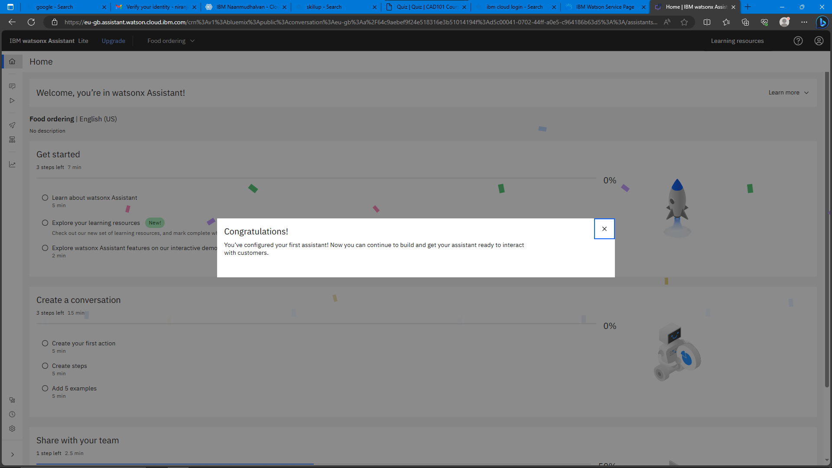

STEP 2:

Here I created my intent named as "#happy","#initial" and "#thanks".

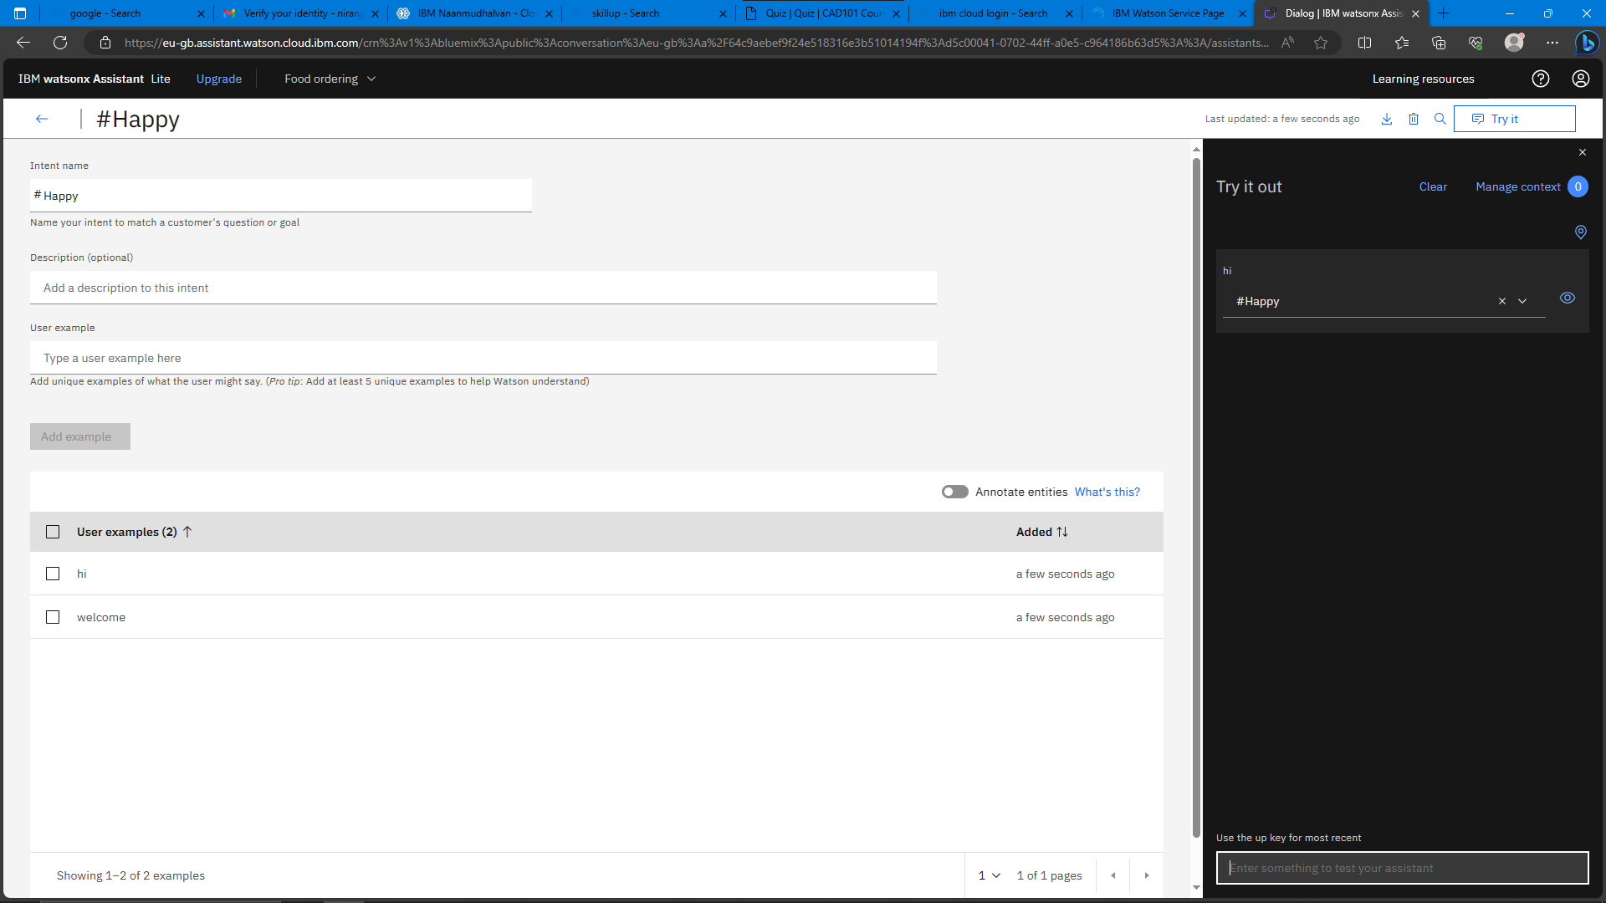

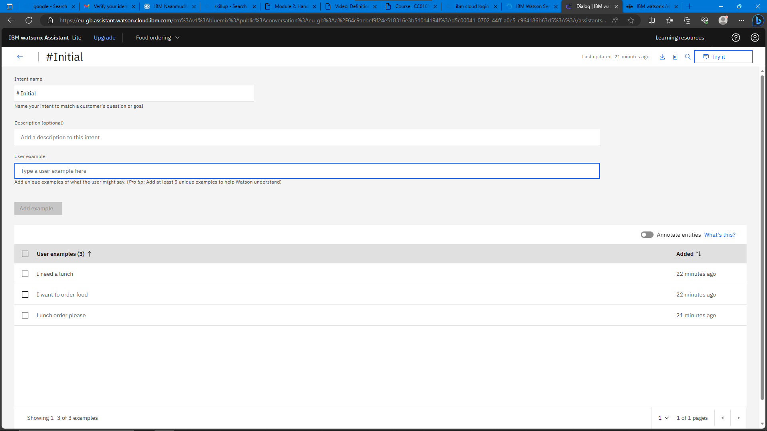

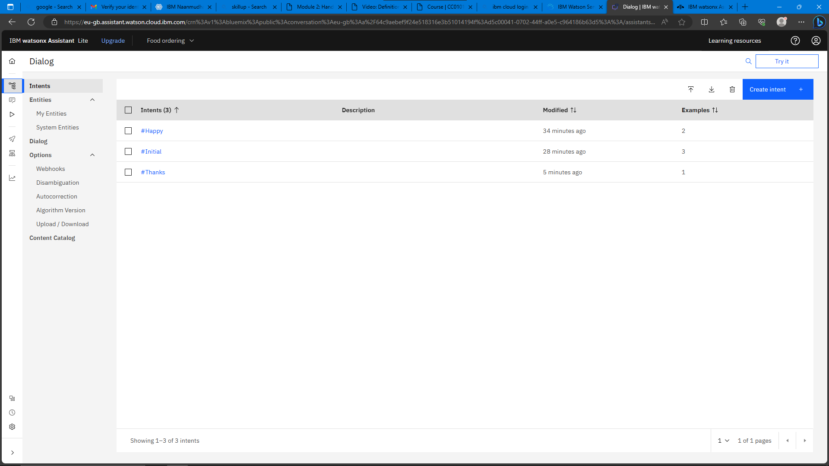

STEP3:

Here created a dialogs to order food .

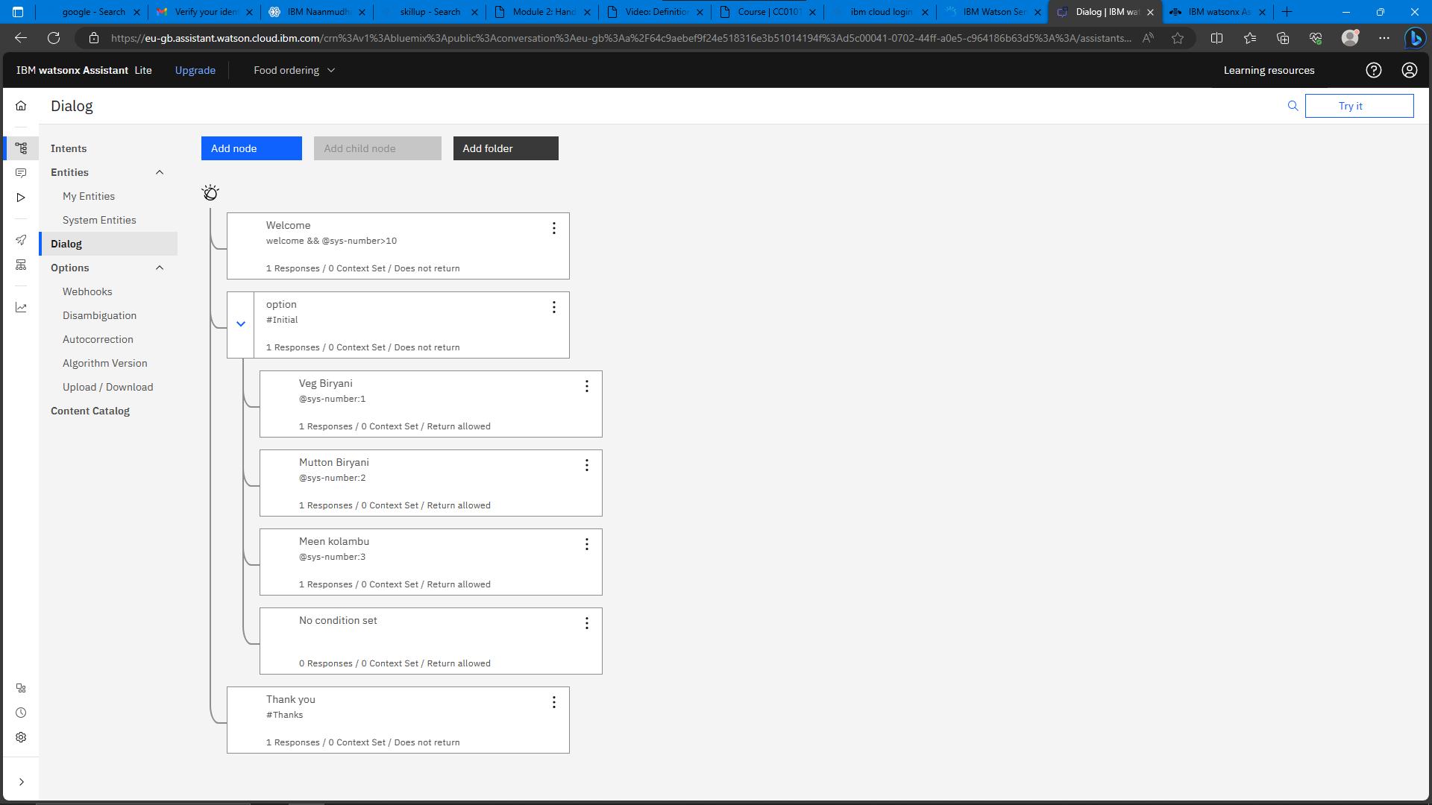

STEP 4:

Here I preview my assistant

